1.
List 3 key differences between Ethernet cables and fiber optic cables, and give one real-world example where each type would be used (for example, home WiFi router, data center, college campus backbone).
Feature | Ethernet Cable | Fiber Optic Cable
Medium | Copper wires transmit electrical signals | Glass/plastic fibers transmit light signals
Speed & Distance | Up to 10 Gbps, effective for short distances | Up to 100 Gbps+, excellent for long distances
Cost & Installation | Cheaper, easier to install | More expensive, requires specialized tools

2.
Draw and label a diagram showing the internal wiring of a straight-through Ethernet cable (use T568B wiring standard), indicating the color of each wire and its pin number.
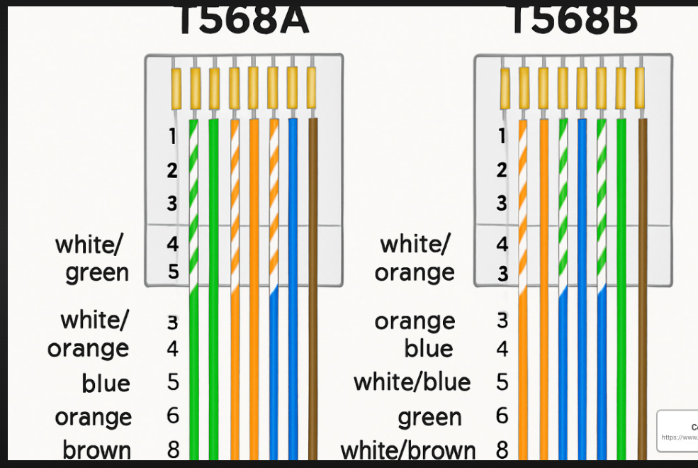

3.
Watch a YouTube video demonstrating how to use an RJ45 crimper, then write a step-by-step guide (in your own words) on how to attach an RJ45 connector to a CAT6 cable.
01
Prepare the Cable
Start by cutting the CAT6 cable cleanly to ensure a proper fit.
- Use a cable cutter to trim the end straight
- Strip about 1.5 inches of the outer jacket using a wire stripper
- Avoid nicking the inner twisted pairs
02
Untwist and Arrange Wires
Arrange the wires according to the T568B standard for consistency.
- Untwist the pairs carefully
- Flatten and align wires in the order: White/Orange, Orange, White/Green, Blue, White/Blue, Green, White/Brown, Brown
- Straighten them with fingers or a flat tool
03
Trim Wires Evenly
Ensure all wires are the same length before inserting into the connector.
- Cut wires to about 0.5 inch beyond the jacket
- Double-check the sequence is correct
04
Insert Wires into RJ45 Connector
Slide the wires into the connector until they reach the end.
- Hold the connector with the clip facing down
- Push wires firmly so each sits in its channel
- Verify the jacket is inside the connector for strain relief
05
Crimp the Connector
Secure the wires by compressing the connector with the crimper.
- Place the connector into the RJ45 crimper slot
- Squeeze firmly until the pins pierce the wires
- Tug gently to confirm a solid connection
06
Test the Cable
Check functionality to ensure proper wiring and connectivity.
- Use a cable tester to verify pinout
- Confirm continuity and correct order
- Retest if connection fails

4.
Imagine you are setting up a gaming café with 10 PCs for LAN gaming. Decide which cable type (Ethernet or fiber optics) and which tool (RJ45 crimper or fiber cleaver) you would use, and explain your choices in 3-4 sentences.<br><br><em><strong>Hint:</strong> Consider speed, distance, and budget for your answer.</em>
For a gaming café with 10 PCs:
- Cable Type: Ethernet (CAT6) is the best choice. It provides high speed (up to 10 Gbps), low latency, and is cost-effective compared to fiber optics. Fiber is excellent for long-distance backbone connections, but unnecessary for short runs inside a café.
- Tool: RJ45 crimper. Since Ethernet cables use RJ45 connectors, this tool is essential for terminating CAT6 cables.
- Reasoning: Ethernet balances speed, reliability, and affordability. Fiber optics would be overkill for short distances and significantly increase costs. Using CAT6 with RJ45 crimpers ensures smooth LAN gaming with minimal lag at a reasonable budget.

